Ministry of Natural Resources and Environment of the Russian Federation

Federal Agency on

Mineral Resources

Federal State Budgetary Institution

“A. P. KARPINSKY RUSSIAN GEOLOGICAL RESEARCH INSTITUTE”

(FGBU “VSEGEI”)



**74, Sredny Prospect, St. Petersburg,**

**Russia, 199106, VSEGEI**

**For telegrams: Saint Petersburg, VSEGEI**

# Phone: +7 812 321 57 06

**Fax: +7 812 321 30 23**

**E-mail:** [**vsegei@vsegei.ru**](mailto:vsegei@vsegei.ru)

Chinese Academy of Geological Sciences (CAGS)

“15” August 2016 No _______________

Dear colleagues,

According to the Protocol of the 13th Workshop on “3D Geological structures and Metallogeny of Northern-Central-Eastern Asia” (Shymkent City, Republic of Kazakhstan October 12-16, 2015), the 14th Workshop under the project “Deep Processes and Metallogeny of Northern-Central-Eastern Asia and Adjacent Areas” (3-6 October 2016, Vladivostok, Russia) at Far East Geological Institute of Russian Academy of Sciences.

We are glad to invite the following Chinese experts to take part at the work of the 14th Workshop:

1. Prof. Li Tingdong, Chinese Academy of Geological Sciences (CAGS)

2. Prof. Dong Shuwen, Nanjing University

3. Prof. Ding Xiaozhong, Institute of Geology, CAGS

4. Prof. Ren Liudong, Institute of Geology, CAGS

5. Prof. Liu Yanxue, Institute of Geology, CAGS

6. Prof. You Guoqing, Institute of Geology, CAGS

7. Dr. Wang Jun, Institute of Geology, CAGS

8. Dr. Liu Yong, Institute of Geology, CAGS

9. Dr. Zhang Heng, Institute of Geology, CAGS

10. Dr. Li Jinyang, CAGS

11. Prof. Wang Xueqiu, Institute of Geophysical and Geochemical Exploration, CAGS

12. Prof. Xiong Shengqing, China Aero Geophysical Survey and Remote Sensing Center for Land and Resources (AGRS)

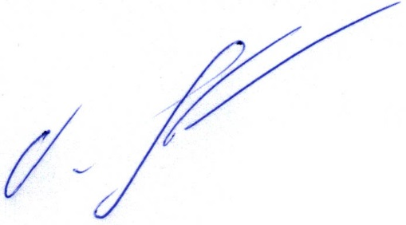Best regards,

Dr. Oleg Petrov

VSEGEI Director General